
TGI Registration System
Version: 1

Documentation

Contents
Page No

User Manual
- Start Application …...…………………………………………………………………………..…………………. 3
- Main Screen and User Interfaces ……………………………………………………..…………..……… 4
- Production Order.……………………………………………………………………………………………….…… 5
- Create Production Order …………………………………………………………………………………….…… 6
- Update Production Order …………………………………………………………………………………….…… 7
- Access Production Order ……………………………………………………………………..…………….…… 8
- Create Installation Plan ……………………………………………………………………..…………….…… 9
- Update Installation information…………………………………………………………..………….…… 9
- Master Maintenance …………………………………………………………………………….…………………. 10
- Update User Password……………………………………………………………………….…………………. 13
- System Modal ….……….……………………………………………………………………….…………………. 14

USER MANUAL

Start Application:

Application can be accessed online and it is compatible with all latest versions of web browsers like Internet explorer, Google Chrome, Mozilla Firefox etc

Direct link to the web program: http://www.arabdemog.com/jj/tgi/

User Name and Password will be provided from the IT Department of PARC – Dubai.

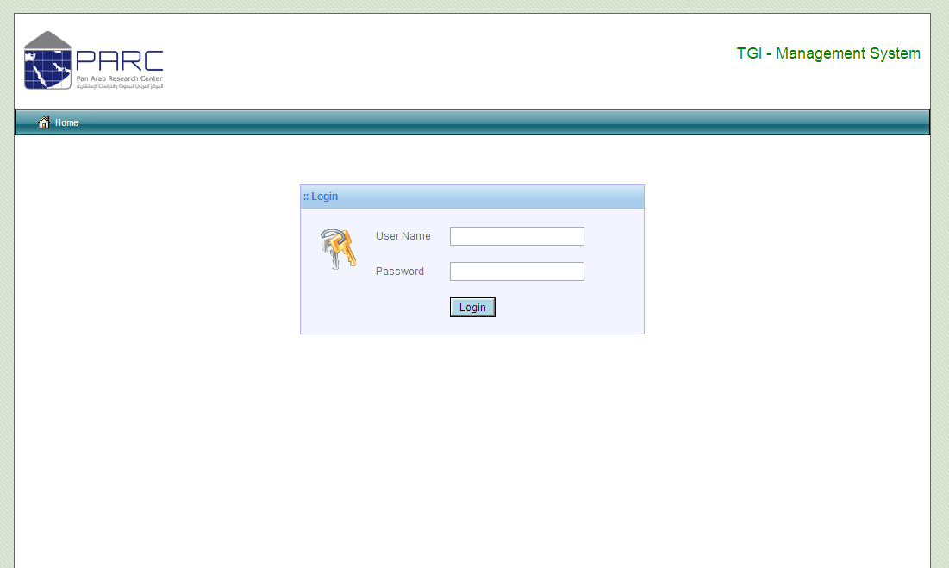

We have 4 types of user roles using here in this system

- Admin – Who can create users for the system and define their roles. Admin can manage all master database files used in the system.
- Accounts – Who can create New Production Order.
- Marketing – Who is creating and scheduling installation instructions.
- Installation – Who is executing installation.
Main Screen and User Interfaces:

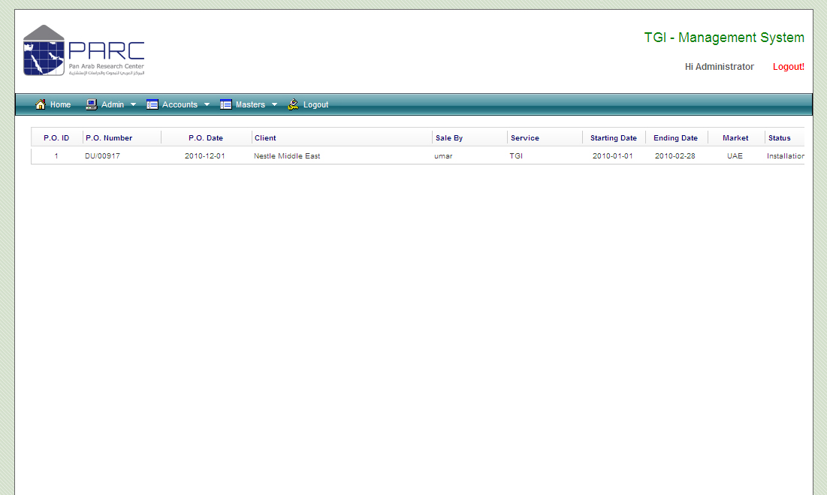

Explaining Interfaces

- Use Menu bar to access software functions.
- By default all available Production Order will list out in your home page (only to which you have access). The Production Order’s status is also visible at the right end.
- Production Order can open for detailed viewing by click on it.
- Cancelled Production order will be marked in light red color and the Production Order executed successfully will be marked as light green.
- All Dates used in the application is “YYYY-MM-DD” formats.

Icons Used and its descriptions

- To Find a Production Order

- For the mandatory data entry fields

- For creating new record in master file

- For Adding selected item to the List

- For Removing selected item from the List.

- For Closing a Data entry Form
Production Order:

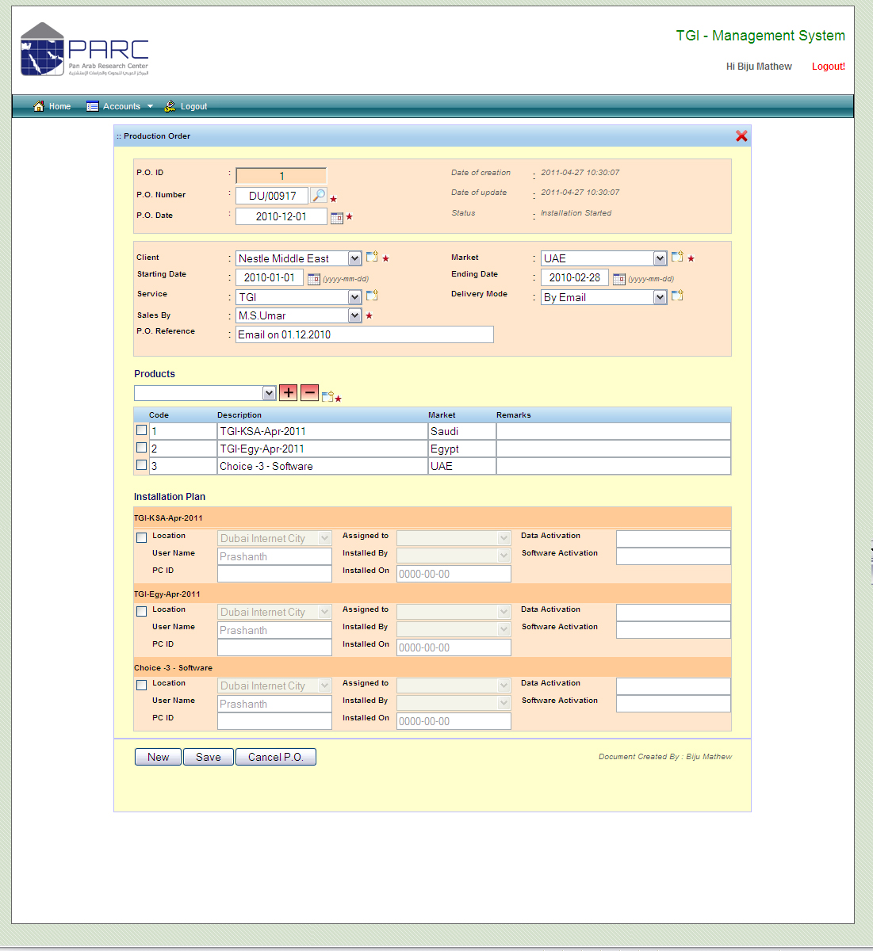

This option allows accounts department to create Production Order (P.O) and its maintenance.

Production order is divided in to three sessions:

- P.O. Information – This is created by Accounts Department and it included the information like client, dates, products etc.
- Installation Plan – This is the selection of products and the instructions to install it at clients end. This is creating by the sales person as per his client’s requirement.
- Installed Information – This is a part of installation plan and it is updating by installation team with the information from client side.
Create Production Order:

This module can be operated only by the user who having the privilege of accounts department.

- Click on Create P.O. from your menu
- Click on New Button
- Enter P.O. Number, Date
- Choose Client – if it not there in your list, you can create it by clicking on “Create New Client” button
- Choose Market
- Choose Starting and Ending Date (YYYY-MM-DD) by clicking on the calendar button
- Choose Service Type - Can create new service
- Choose Delivery Mode
- Choose Sales Person
- Add products to the list
  - Choose products and click on add button, if products not existing then click on Add new products. You can remove added products by selecting it and click on remove button

- Click on Save button to Save your P.O.

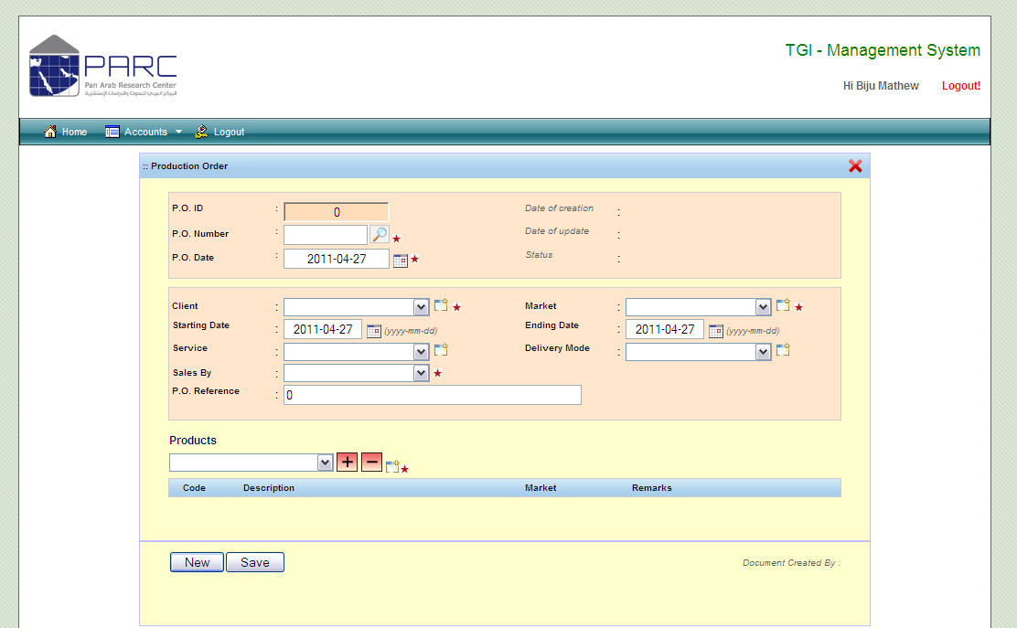

Update Production Order:

This module can be operated only by the user who having the privilege of accounts department.

- Click on Create P.O. from your menu
- Click on Find button near to P.O. Number
- Click on the P.O. of your choice and system will load that P.O. in your screen
- Make necessary modification and Click on Save button
- Cancelled P.O. are not able to update
- An Email will send to Sales and Installation Department by mentioning the updation of a P.O.

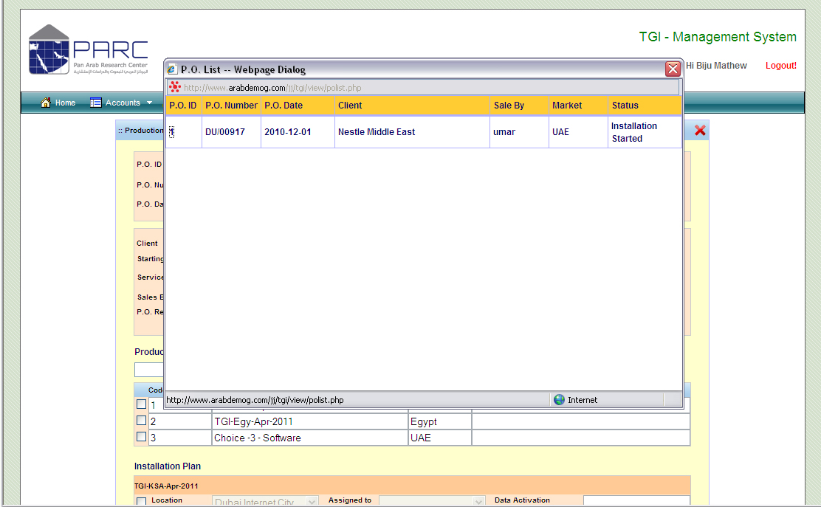

Note: You cannot delete a P.O. But can cancel it.
Access Production Order

Production orders can be accessed from the home page itself. By default all the available production orders will list in your home page with its current status. By click on it you can have full view of this document. Or else you can use Find Button from the P.O. Maintenance screen which resides next to P.O. Number.

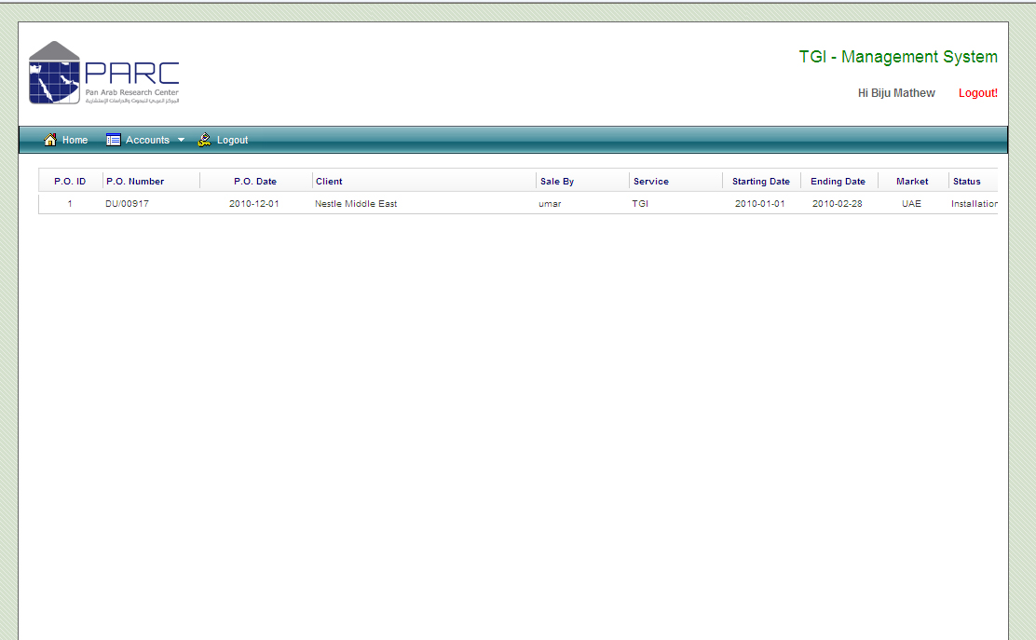

Create Installation Plan

Sales person have to create Installation plan as per his client’s requirement.

- Sales person will receive an email from System once a P.O. is created.
- Login to the system
- Click on the P.O. and open it in detailed view
- Click on Add new installation Plan button
- Select the Location Available or create new location by clicking on the “Location” label
- Enter the name of the user
- Make one entry for one installation.
- Click on Update Plan
- An Email will forward to Installation team

Update Installation information

IT person will update this information by login into the system.
The information collected from client during the time of installation will be updating here.

- Login to the system
- Choose P.O.
- Update Client PC information
- Update Software keys assigned to that client
- Click on “Update Install Plan”

Master Maintenance:

Master files can be updated while you are entering P.O. data. But Administrator has a privilege for updating all master files from main menu.

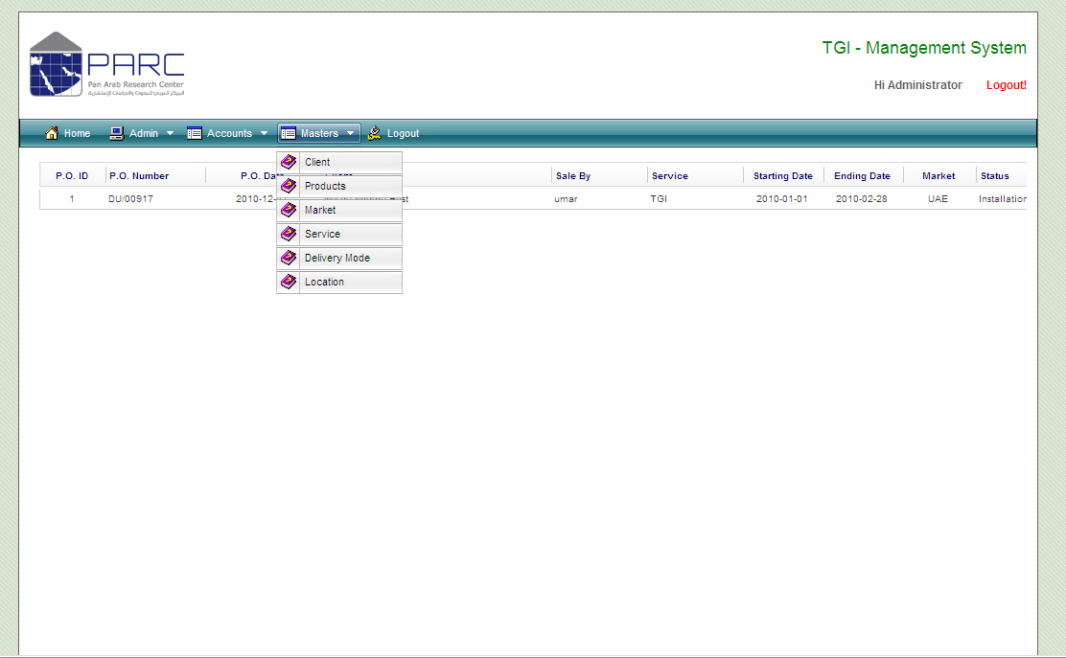

Client Master

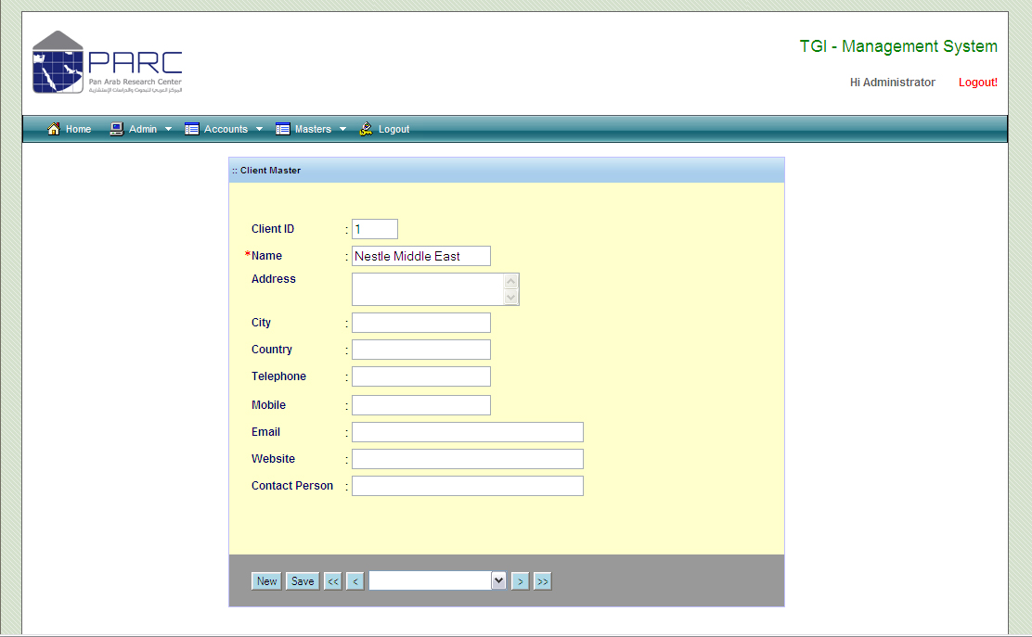

Products

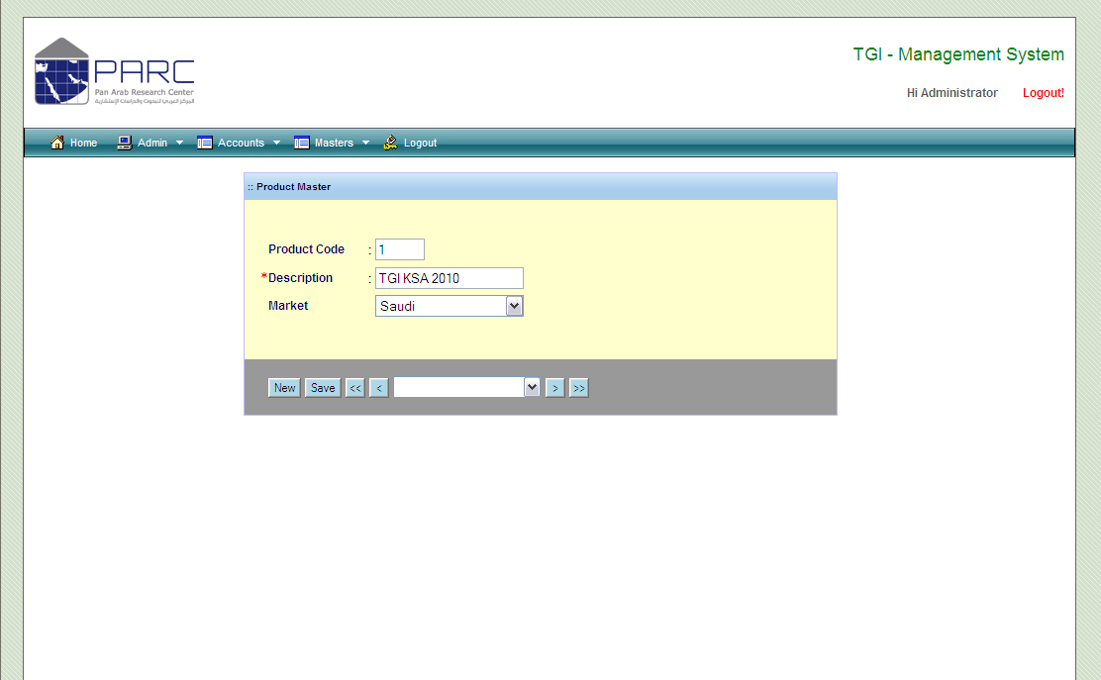

Market

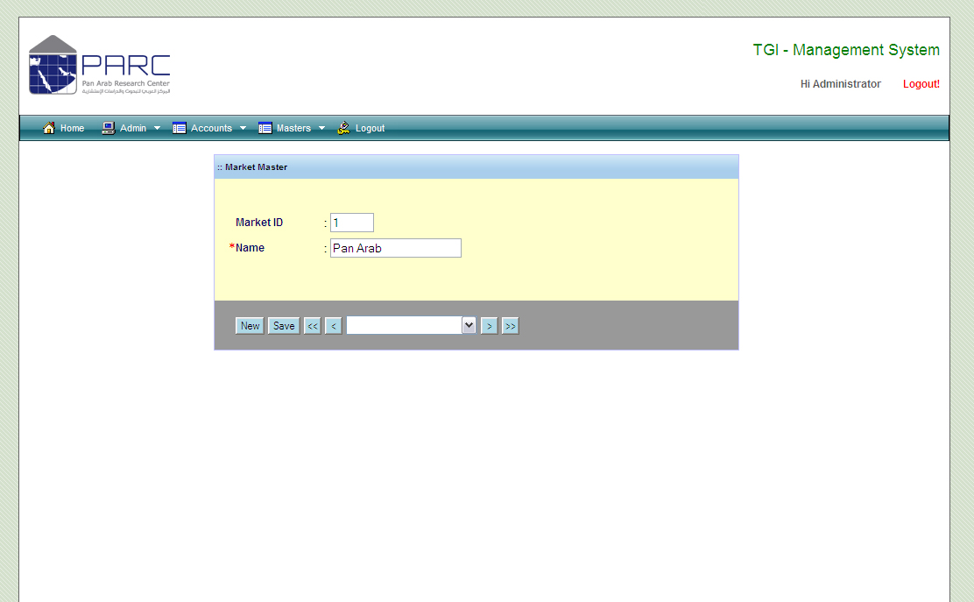

Service

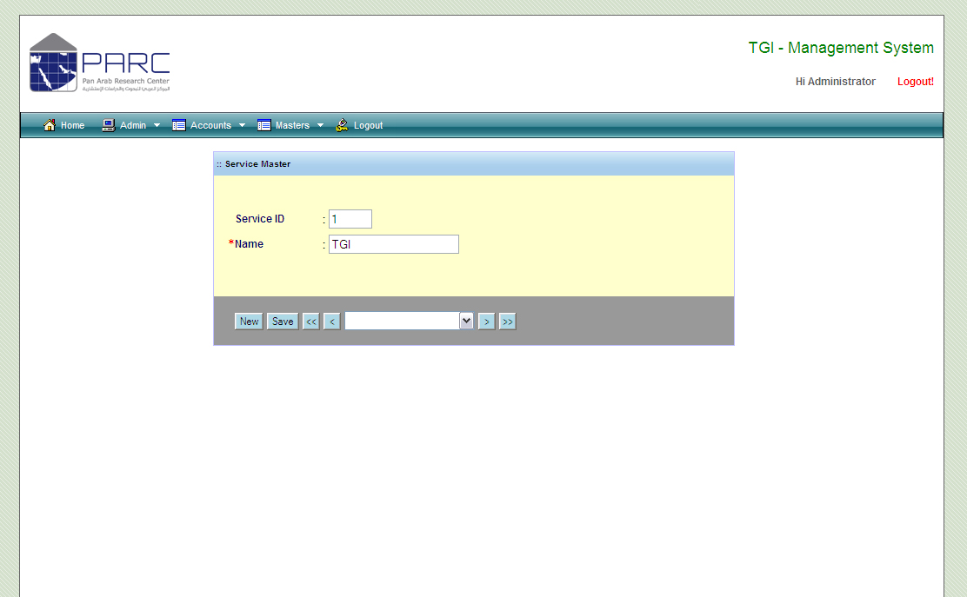

Delivery Mode

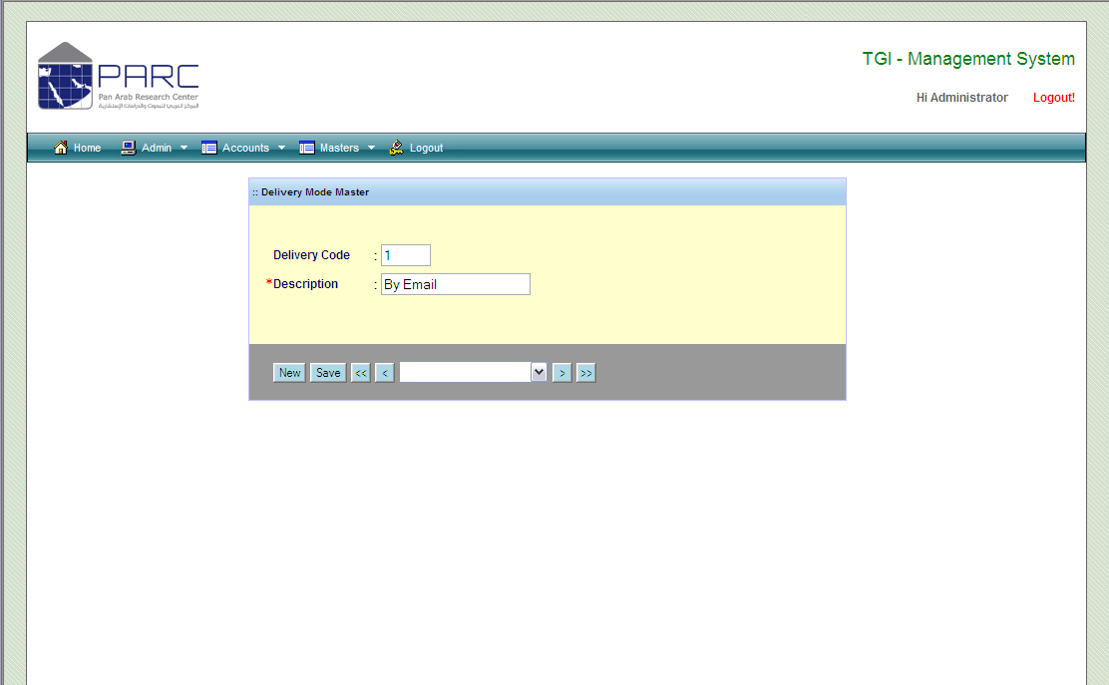

Location

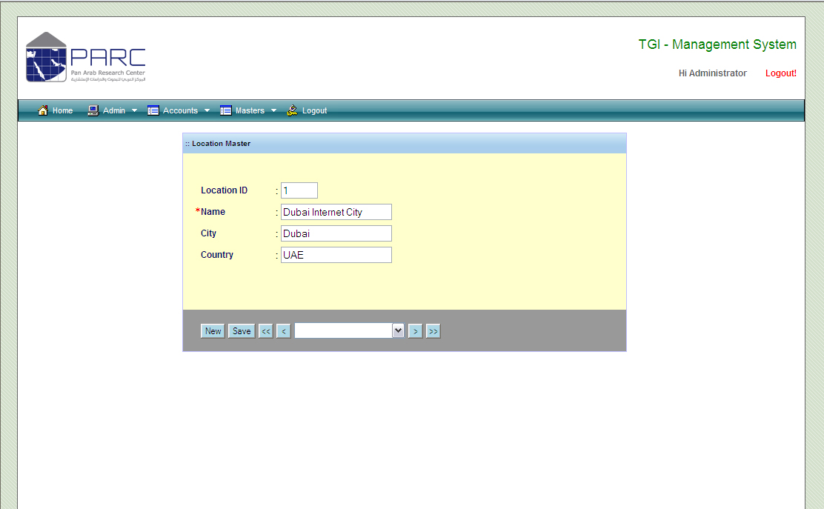

Update User Password

- Login to the system
- Click on the User Name from the Right Top of the Screen
- Enter New password and enter Confirm password
- Click on Save button

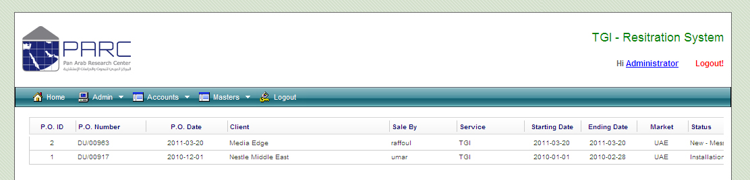

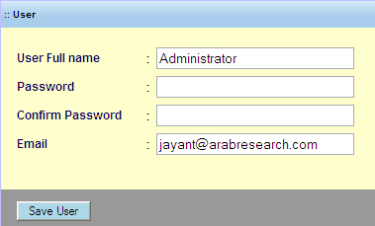

System Modal:

