Software Requirement Specification for

PARC Report Gallery Web Application

Contents

1. **Project Title**
2. **Description**
3. **Functional and Non functional Requirements**
4. **Technical Architecture Diagram & Details**
5. **UML diagrams**
6. **Data Flow Diagram (DFD)**

PARC Report Gallery

**Topic : PARC Report Gallery - An on-line research report gallery.**

**Project Title : PRG**

**Description:**

This product is intended to the clients who use the facility of internet for exploring the research resources for analysis and development. The main function of the product will be the sales of research reports by utilizing the opportunity of web technologies. This web based application can organize the research reports of PARC in a categorized order to make it readily available to the researchers who required it. The clients can come and visit over the report Gallery and select their reports in to their carts and can request for the delivery of a complete report. The purchased report will be delivered to the client’s email address or to their door step by courier under the responsibilities of PARC. An invoice will send to the client at the end of each transaction.

Application will be Web Based (Browser Based). There will be Separate Control Panel for Users and Admin (Super User). Users can add Own Profile and browse reports products to buy based on categories and regions

There are mainly two categories of users who can use this application

1. Users
2. Admin

Functional Requirements

**User Module:**

* Register User Profile
* User login using email and password
* Browse Report Gallery
* Search Reports by category and region
* View Transaction History
* Add reports in the cart to purchase
* Choose Delivery Mode
* Request Delivery or Checkout Cart using PayPal
* Initiative request for non available reports
* Submit comments and remarks about the report.

**Admin Module:**

* Manage Users Profiles
* Update Report Gallery
* Manage Report Categories and Region
* User Transaction History
* Response to Customer Queries

Non functional Requirements

**PHP**

PHP is a general-purpose server-side scripting language originally designed for Web development to produce dynamic Web pages. It is one of the first developed server-side scripting languages to be embedded into an HTML source document rather than calling an external file to process data.

**Mysql**

MySQL is the world's most used open source relational database management system (RDBMS) that runs as a server providing multi-user access to a number of databases.

The MySQL development project has made its source code available under the terms of the GNU General Public License, as well as under a variety of proprietary agreements. MySQL was owned and sponsored by a single for-profit firm, the Swedish company MySQL AB, now owned by Oracle Corporation.

**HTML**

HyperText Markup Language (HTML) is the main markup language for displaying web pages and other information that can be displayed in a web browser.

HTML is written in the form of HTML elements consisting of *tags* enclosed in angle brackets (like <html>), within the web page content

The purpose of a web browser is to read HTML documents and compose them into visible or audible web pages. The browser does not display the HTML tags, but uses the tags to interpret the content of the page.

**CSS**

Cascading Style Sheets (CSS) is a style sheet language used for describing the presentation semantics (the look and formatting) of a document written in a markup language.

CSS has a simple syntax and uses a number of English keywords to specify the names of various style properties.

**Javascript**

JavaScript (sometimes abbreviated JS) is a prototype-based scripting language that is dynamic, weakly typed and has first-class functions. It is a multi-paradigm language, supporting object-oriented,[5] imperative, and functional[1][6] programming styles.

**Jquery**

jQuery is a cross-browser JavaScript library designed to simplify the client-side scripting of HTML.[1] It was released in January 2006 at BarCamp NYC by John Resig. Used by over 55% of the 10,000 most visited websites, jQuery is the most popular JavaScript library in use today.

jQuery is free, open source software, dual-licensed under the MIT License or the GNU General Public License, Version 2.

**MVC**

Model–View–Controller (MVC) is a design pattern for user-facing software that separates the representation of information from the user's interaction with it. The model consists of application data and business rules, and the controller mediates input, converting it to commands for the model or view. A view can be any output representation of data, such as a chart or a diagram. Multiple views of the same data are possible, such as a pie chart for management and a tabular view for accountants. The central idea behind MVC is code re-usability and separation of concerns.

**Technical Architecture Diagram**

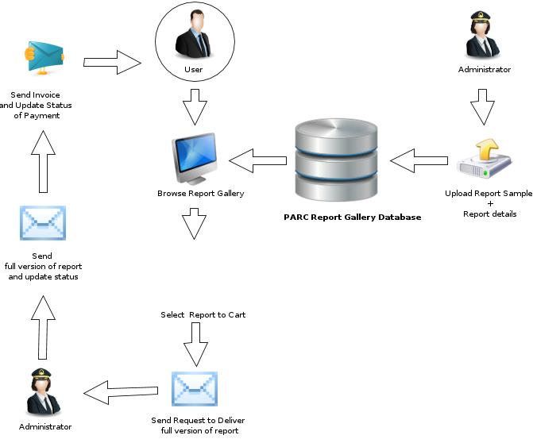**Use case diagram for User.**

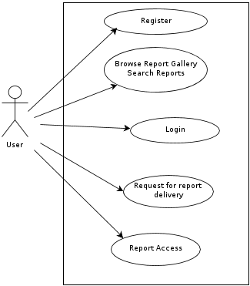**Use case diagram for Admin.**

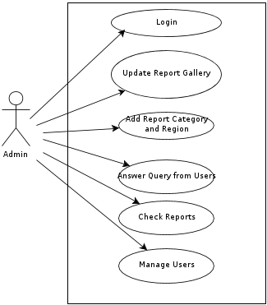

**Data Flow Diagram**

